
Why & What is Affiliate Marketing

Affiliate Marketing is where you (the affiliate) generate sales for some other product vendor(s) and in exchange they pay you a commission for each sale that you make.

Some affiliate programs are “continuity” programs in that they require that the customer pay a monthly fee for membership or for use of that product.

Advantages:
- Super easy to promote third party products and keep commissions (50%-100%)
- Just need to drive traffic
- No headache of product creation
- No technical knowledge required
- Can lead to “high ticket commissions”

How to Find Best Converting Affiliate Offers (Secret Vault no. 1)
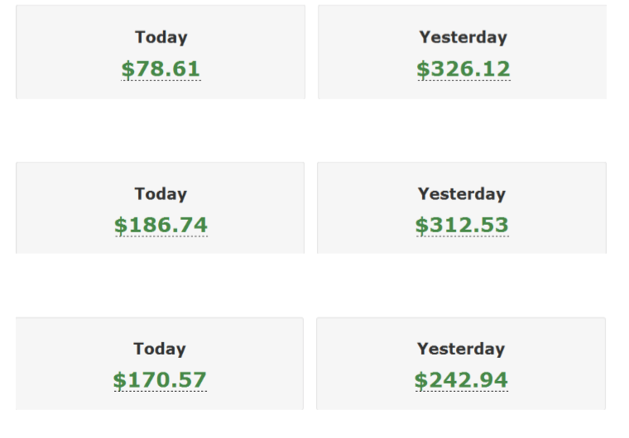
Introducing you to my personal vault of finding high converting affiliate offers which has helped me to generate passive paydays like these:

Welcome to Warrior +
Follow these exact steps to start encashing from high converting offers:
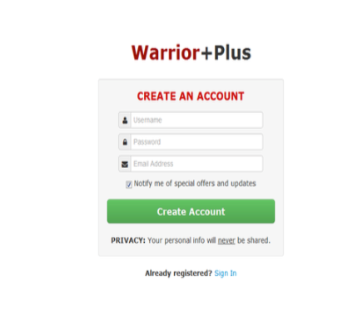
Step #1: Visit www.warriorplus.com & create an account for free.

Make sure to have a working PayPal account to receive payments.

Step #2: In order to find high converting offers inside W+, click on “Affiliates” and search by either “Pulse score” or “Conv. Rate”
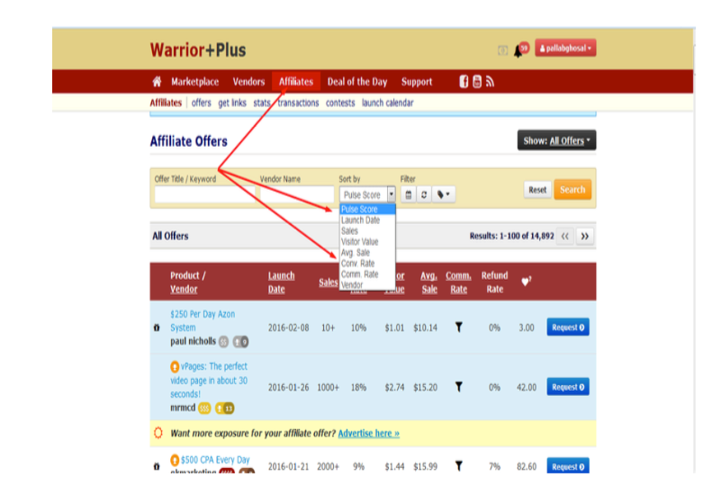

Step #3: Always choose offers that have a “Pulse score” above 30 and minimum 10% conversions.
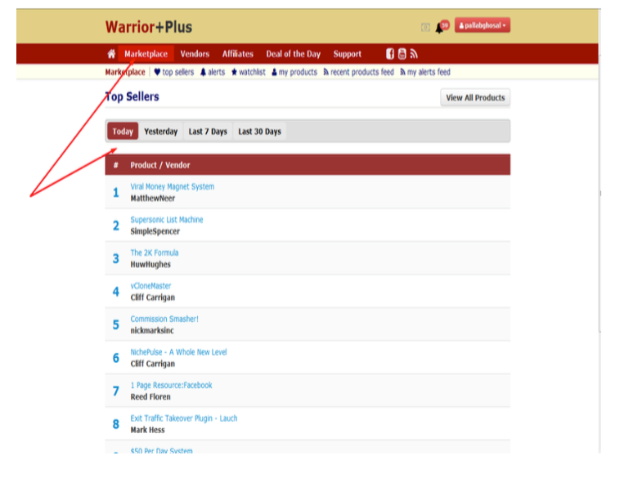
Step #4: Another smart way of finding high converting offers is by visiting “Marketplace” and clicking on “top sellers”.
Step #5: Request for product approval. You will be notified via email once your request is approved.

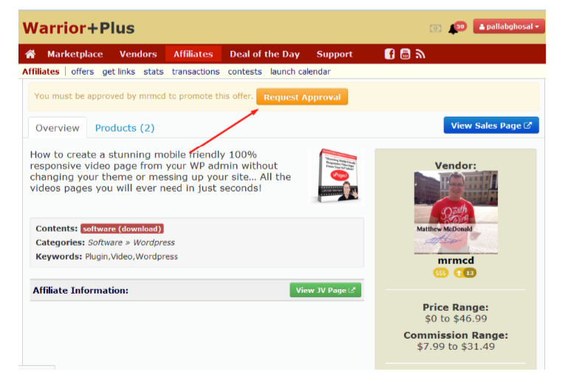
Step #6: Now start driving traffic (following the later modules of this guide) to these offers and enjoy money been deposited in your PayPal ☺

