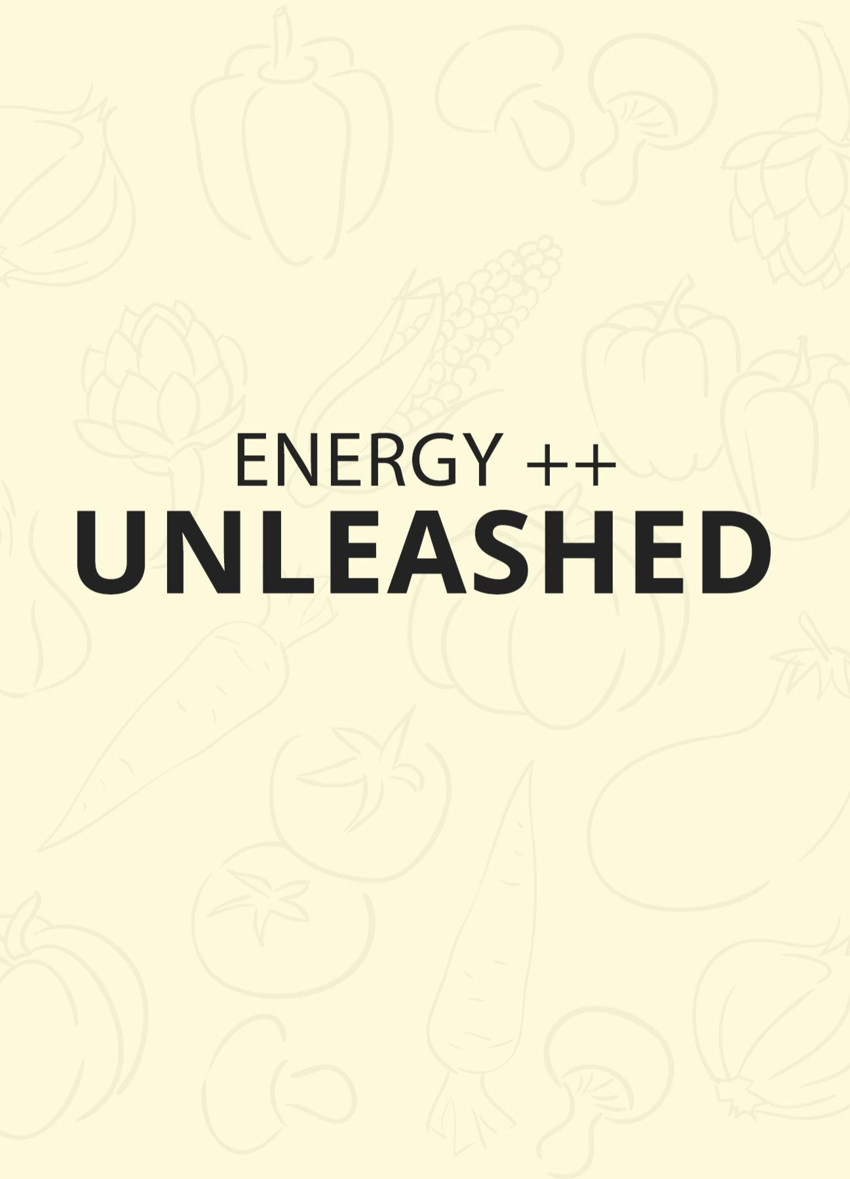
How to Have the Ultimate Productive Day by Supercharging Your Energy Levels

If you read lifestyle, health and tech blogs, then you’ll find that there is really no shortage of advice out there when it comes to increasing your productivity and getting more done in a day. Of course not all of that advice is equally useful but nevertheless, if you know where to look, then you should have not problem finding ideas that can help you out.

The question is then: what nwould happen if you were to take all those most effective tips and strategies and combine them on one single day? Could you create yourself an optimal state of mind and an optimal environment for getting the most work done possible? And what would that look like?

In this short guide, we’re going to look at what happens when you do everything right and when you take all the best advice for boosting your energy levels and improving productivity. At the same time, we’ll be incorporating some slightly more advanced stuff and high-level tips that you won’t come across in your typical productivity blog.

Follow this blueprint for the most productive, focussed and high-energy day ever.


Energy is the Key

Make no mistake though; energy is very much the key here. Your productivity is predicated on you being able to not only increase your energy levels but also anticipate them and work with them in order to ensure that you’re raring to go when you need to be and able to unwind and relax when you need to as well.

And this is a big change of pace for many people, as far too many of us will take energy for granted. We think an awful lot about time management but very often we completely overlook energy management.

But if you sit down at the desk to work and you feel completely exhausted and overworked from the day before. If you feel like you didn’t get enough sleep, or your body is fighting off the remains of a cold… well then you’re not going to find yourself motivated enough to get productive.

So the best tips to follow for that ‘most productive day ever’ are the ones that focus on energy primarily.


The Day Before…

To be highly productive tomorrow, you need to start getting things into place today. This is very important to recognize as your energy levels and focus on any given day are very often the result of cumulative results from the days that preceded it.

The first thing you need to do today in order to be more productive tomorrow then, is to leave a bit of work unfinished.

This might come as a big surprise and seem counterintuitive; but actually, leaving work incomplete is a great way to encourage yourself to work harder tomorrow. The simple reason for this is that we don’t like leaving things unfinished. You’ll be driven by an unconscious urge to complete the task you half-finished tomorrow and this will help you to dive back into ‘work mode’.

And of course the other thing you need to do is to get the best possible night’s sleep. This is going to help you to wake up feeling as good as you possibly can tomorrow and it’s actually far more important than any other aspect of your routine. If you want to perform your best, then getting better sleep is the single best upgrade that you can possibly benefit from.

So how are you going to make sure you get the best night’s sleep?

First: make sure that you take a good half-an-hour-to-an-hour of downtime before you hit the sack. The big mistake that too many of us make, is to work incredibly hard all day, then to come home and watch loud TV or play computer games while checking our phone.

This is devastating for our ability to sleep. All that action on the screen stresses out the brain and makes it more active and alert. Meanwhile, the light is interpreted by our limbic system as being daylight, meaning that we feel more awake and our brain will be flooded with cortisol.

But if you take half an hour to unwind and settle down, then the low-light that comes from outside or from a small, orange, desk-lamp, will help your brain to realize it’s bed time. Meanwhile, concentrating on something to read for example, will prevent your mind from wandering and help you to get into an almost meditative, restful state. Reading also has the considerable advantage of making our eyes tired as we strain to read the text. This causes them to feel heavy and eventually it will be hard to keep them open!

Doing all this will ensure you get to sleep much faster and when you do sleep, you’ll sleep more deeply. At the very least, try to avoid keeping your phone in the room with you when you sleep.

Second: make sure your environment is dark, comfy and quiet. This should go without saying but it’s something that many people don’t take seriously enough. If your room is flooded with light from a nearby streetlamp or if you can hear the neighbors entertaining their guests, then you won’t sleep as well and you’ll feel it tomorrow. At the very least, you should try to cover up bright LEDs (another reason to charge your phone in another room!).

Finally: get your temperature right! Your room should be slightly cool when you’re sleeping so you have to stay under the covers for warmth. And while you’re at it, consider taking a nice warm bath before bed. This will relax your muscles and help you to regulate your body temperature throughout the night.


Wakey, Wakey…

Here’s one more tip for sleeping, this time dealing with the way you wake up: get yourself a ‘daylight lamp’. These are lamps that are designed to create a wavelength that is purposefully similar to that of the sun. Better yet, they will get brighter gradually in the morning before the alarm sounds. What this does is to gently stir you out of deep sleep by making the environment seem to get slowly brighter. This means that when the alarm does sound, you will be in REM sleep rather than SWS (Slow Wave Sleep). That in turn means you’ll feel much less groggy.

Better yet, you’ll be waking up into a bright room – which makes a huge psychological difference and makes it much easier to get up and get going!


To Coffee or Not to Coffee

So if we’re trying to do everything right and boost our energy levels as much as possible for the day ahead, the next question is whether or not we should drink coffee.

And the answer? Kind of.

When you drink caffeein, this helps the brain to feel more awake by blocking the effects of adenosine. Adenosine is a by-product of the energy process in the brain. When the cells utilize glucose and ATP to help us go about our daily activities, they create adenosine as a by-product. Unfortunately, this by-product then dampens activity of the cells, making us feel groggy and sleepy. This is why we get tireder and tireder throughout the day, until we eventually fall asleep and the brain is able to flush itself of the substance.

Except it isn’t all gone in the morning and this is one of the reasons that you’ll often experience sleep-inertia and still feel tired when you first wake up.

Caffeine mimicks adenosine and this means that the brain ‘mistakes’ it for that by-product. Caffeine therefore is able to bind to the adenosine receptors, which prevents adenosine from working. Hence, you wake up.

So that’s a good thing right?

Sure, but it’s not the only factor to consider.

For one, blocking adenosine and waking the brain up artificially causes a surprising amount of activity across the brain. Our body finds this unusual and so it responds by releasing more stress hormones – thinking that we must be doing something very important, or that we might even be under attack!

Hence we produce adrenaline (norepinephrine), cortisol and more. Caffeine in that regard is ‘stress in a cup’ and stress is not good for our energy levels.

The other issue with caffeine is that the brain can adapt to it. When you have low adenosine activity in your brain for long enough, it can respond by trying to upregulate it. That means it will increase the number of adenosine receptors, meaning that you now need more caffeine in order to block them. It also means that when you don’t get caffeine, you can feel even more tired – which is why caffeine is addictive. This can even cause headaches via caffeine withdrawal.

So should you drink caffeine or not?

A good compromise is to drink a little caffeine and to time it right throughout the day. Morning is a good option, especially if you take weekends off.

And instead of coffee, consider drinking tea for a more gentle release of caffeine. Better yet, why not combing that caffeine with a bit of l-theanine via supplementation? This will help you to feel more awake through the caffeine but the l-theanine will ‘take the edge off’ so to speak and prevent the stress response that comes from caffeine. L-theanine is a xanthine like caffeine and occurs naturally in green tea – but instead of acting as a stimulant, it has a calming and de-stressing effect. When taken together, these two compounds are highly synergistic and a great way to start your day!
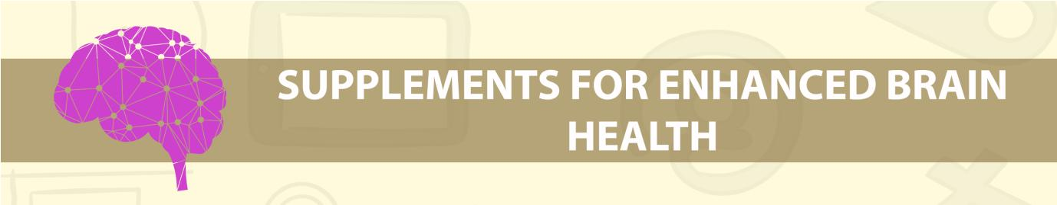

Supplements for Enhanced Brain Health

Seeing as we’ve already enjoyed such lively debate on the topic of caffeine, what about other supplements you can use to enhance your energy levels and thus focus harder at work? Is there anything you should consider taking in the mornings?

One option is modafinil. This is a ‘nootropic’ or ‘smart drug’ enjoyed by some of the world’s most well-known 1%ers. What’s amazing about this substance is that it can actually prevent you from feeling as though you need to sleep by subtly affecting your ‘orexin’ neurotransmitter. Originally, it was designed to help people overcome narcolepsy but today it is used by people like Dave Asprey in

order to work longer hours without feeling fatigued. So if you’re looking for a way to feel less tired and more focussed and energetic for work, this will certainly do it!

Unfortunately though, modafinil is only available on prescription in most stats. And while this drug might not have any known side effects, it needs a lot more study and research before we can safely pronounce it as ‘safe’ for long term use.

Fortunately though, there are plenty of other more natural ways to give your brain a bit of a kick and feel more awake and focussed for work as a result.

Supplements for Boosting Brain Energy

Creatine is a supplement used by bodybuilders and athletes to give them more energy in the gym and on the track. It works by allowing the body to recycle used ATP (ADP and AMP). ATP is adenosine triphosphate – three molecules bonded together which release energy when broken apart to make ADP and AMP (adenosine diphosphate and adenosine monophosphate). In short, a three makes a two and a one. The body can use creatine, which is also produced naturally in the liver but supplementing can give us energy to make a few more lifts in the gym, or to run a little faster, a little further.

And of course this also improves brain function and has been shown to provide additional improvements in memory and an overall IQ boost.

Garlic meanwhile is a vasodilator. This means that it widens the blood vessels, which allows more blood and oxygen to be delivered to the brain, providing yet more energy. Vinpocetine is a vasodilator that acts specifically in the brain and is also anti-inflammatory (brain inflammation is suspected by some to be responsible for mood disorders). Omega 3 fatty acid aids in the communication between neurons by improving cell membrane permeability (in other words, the cell walls let more nutrients and neurotransmitters pass through).

Coconut oil is another popular cognitive metabolic enhancer as it contains MCT oil – medium chain triglycerides. This type of fatty acid stimulates the liver to produce ketones immediately providing an alternative source of energy to carbohydrates for the brain (which the brain actually prefers for some functions).

Also great are those nootropics and substances that improve cellular energy including energy for the brain cells. Some of the best include CoEnzyme Q10, Lutein, L-Carnitine and PQQ – though you can expect a marginal effect from all of these and it’s worth noting that simply adding some cardio training will likely be more efficient at increasing cellular energy rapidly.

Now, if you combine these ingredients for breakfast, then you should find that you’re better able to improve your energy levels and your focus throughout the day that follows!

Nutrients and Diet

What’s also crucial is to provide your brain with as many of the best nutrients as possible which can support healthy and normal function beyond the average. Vitamin B6 for instance is used in the creation of dopamine, serotonin and many other key neurotransmitters. Of course amino acids found proteins are also used in the creation of many neurotransmitters (tryptophan for instance is a precursor to serotonin and melatonin), while zinc (which many of us are deficient in) modulates brain excitability, supports testosterone production and aids with neuroplasticity (see the next chapter). Vitamin D helps regulate hormones and improves sleep, while many more vitamins and minerals play a range of other vital roles.

You can spend a lot of money on supplements and nutrients to try and enhance brain function and they will have some effect. But more effective and efficient is to get the same thing from your diet. This is why a nutrient dense diet is so important as stressed at the start of this book. Eat lots of organ meats and you will get your CoQ10 and PQQ. Eat lots of fish and you get the omega 3.

The other important aspect of your diet is simply that you ensure you are eating enough. In other words, don’t start yourself – and try to eat frequently throughout the day.

Ideally, you’ll start with some form of ‘complex carb’ for breakfast. A complex carb is a carbohydrate that the body takes longer to absorb into the blood stream. This means you’re eating something like oats rather than something like chocolate cereal or toast. By absorbing slowly, this ensures you’ll have a gradual supply of sugar throughout the day. Fats are similarly slow-releasing and that’s why an avocado is another great choice for breakfast. Start your day with these types of foods and you should find that you’re able to remain working vigilantly for long periods and without succumbing to fatigue.

Another tip? Snack throughout the day! Don’t go long periods without food, as this will cause your body to use up its supply of sugar and your brain will start to get sluggish – you may also start to notice yourself feeling anxious as a result. Keep fuelling yourself and you’ll avoid running on empty.

So we’ve woken up naturally, had our hot beverage and now we need to have breakfast. That should be:

- Nutrient dense

- Slow releasing to last us a long time

- Washed down with some cognitive metabolic enhancers

Now we’re ready to go!


Approaching Work

Now you’re at work and hopefully feeling supercharged, you need to try and maintain those high energy levels throughout the day.

The first way to do this is to avoid wasting energy on things you don’t need. To do that, you should try to keep distractions and interruptions to an absolute minimum. One good first step is to turn off email notifications and to encourage people not to call you. Create points during the day when you will handle correspondence and set up autoresponses to ask colleagues and partners to be patient in the meantime. This is advice often shared by Tim Ferriss, who authored TheFour Hour Workweek.

Note that you can also be interrupted by your own stream of thought. This is why it’s important to block out anything that might cause distraction while you work on big tasks. A good starting point is to think about closing ‘open loops’. These are things like emails you need to answer and other small

jobs you need to complete. These are small annoyances but when you eliminate them from your mind, they can’t detract from your ability to work on the big jobs that really matter.

Complete these small jobs in the morning while you come around and then move on to big tasks so that you can work without distractions. Remember: putting off an important call will not make it go away, it will just make you less productive and drag out the stress for longer.

And lastly, recognize that your energy is finite and that you can’t keep working solidly all day without taking breaks. There will come points when you tire, so make sure that you have taken that into account by scheduling points where you can break and let your energy recover. Don’t try and force yourself to push through those mental blocks: respect your body’s natural rhythms and try to alternate between periods of high output and periods of relative calm.

Keep in mind that we are most creative when we’re relaxed. So this would be the perfect time to solve problems and to come up with unique ideas, before you use the ‘high energy’ periods to execute on those creative ideas.

Closing Comments

Follow all these tips and you should find that you have much more energy and drive to bring to your work. There’s much more you can do too though and if you really want to enhance your energy levels, then you need to think about changing your entire lifestyle and the entire way you approach work. Check out the full ebook if you want to learn more and truly transform your energy levels.

